Nexora membership setup and products
Document 11 of the Nexora learning guides
Source snapshot 14 October 2026 at 06:41 UTC
Understand lookup values, membership products, prices and portal product settings.

Recognise the screen and its scope
Open /membership/setup, /membership/setup/[kind]. CRM routes use port 3017; member routes use 3018; public website routes can use 3019. Brackets name a route parameter, not text to paste into a browser. Choose a real record or site id from the application.
This guide covers Member Type; Member Category; Member Subscription Band; Member Rate Type; Member Rate; Member Status; Member Application Status; Membership products and portal eligibility settings.
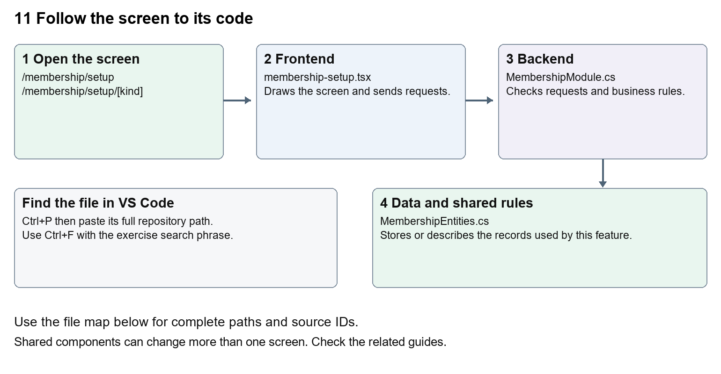
The diagram shows the file roles. The full paths below are what you paste into Ctrl+P.

Find the files in VS Code
Role | File and source ID | What it does
Screen | S0113 membership-setup.tsx | Main UI or route for this topic
Server | S0512 MembershipModule.cs | Endpoints or server rules
Data | S0418 MembershipEntities.cs | Data shape or persistence structure

Screen S0113
apps/web/src/features/membership/membership-setup.tsx
Server S0512
backend/src/Modules/Nexora.Modules.Membership/MembershipModule.cs
Data S0418
backend/src/Modules/Nexora.Modules.Membership/Domain/MembershipEntities.cs
The complete HTML manual opens these source IDs inside its Source library. The Word manual shows short labelled extracts so you can learn the flow before reading large files. Each individual Markdown guide includes its complete primary files after the walkthrough.

Follow the request and the records
1. The setup route checks that the kind is in setupKinds.
2. MembershipSetup loads /setup/{kind}.
3. Authorised staff add or patch lookup names and descriptions.
4. Product settings specify term, rate, currency and portal application options.
5. The server stores these values and validates application requests against the product.

Read the code with an explanation
The seven setup-kind keys are identifiers used by routes and stored records; their labels are the words shown to people. A product connects business settings such as term and rate to an application. Changing a display label differs from changing a key. Existing prices and classifications need a considered migration or business update, not a global text replacement.
Source reference S0113 apps/web/src/features/membership/membership-setup.tsx
Selected opening lines with their original numbers. The complete file is in the HTML source library.
0001 "use client";
0002 import { EntityHeading } from "@/components/ui/entity-heading";
0003 import { useEffect, useState } from "react";
0004 import { moduleApi } from "../shared/module-api";
0005 import { ColumnChooser } from "../shared/column-chooser";
0006 import { useEntityListing } from "../shared/entity-listing-controls";

The import lines lead to shared components and helpers. Start at the exported component or route function; follow the request helper to the server rather than assuming the whole feature lives in this file.
Source reference S0512 backend/src/Modules/Nexora.Modules.Membership/MembershipModule.cs
Extract from source line 54. A fragment from a long line is shown without the rest of that line.
0054 api.MapGet("/setup/{kind}", async (string kind, MembershipDbContext db, CancellationToken ct) =>

On the server, look for MapGet to load records, MapPost to create or perform an action, MapPut or MapPatch to change data, and RequireAuthorization for permissions. Some shared methods register endpoints indirectly. Find SaveChangesAsync to see the database write. A request method alone does not tell you every side effect.
Source reference S0418 backend/src/Modules/Nexora.Modules.Membership/Domain/MembershipEntities.cs
Selected opening lines with their original numbers. The complete file is in the HTML source library.
0001 using Nexora.BuildingBlocks.Domain;
0002 namespace Nexora.Modules.Membership.Domain;
0003 public sealed class MembershipProduct : TenantEntity
0004 {
0005 public string Name { get; set; } = "";
0006 public string Category { get; set; } = "";

Follow model fields to their request names and database mapping. An id points to a particular record. A tenant id limits the organisation. A version or concurrency stamp protects newer edits. Some model files describe contracts rather than tables; check the owning DbContext before assuming storage.

Make or trace your first change
1. Press Ctrl+P and open apps/web/src/features/membership/membership-setup.tsx.
2. Press Ctrl+F and search for Lookup values. In this snapshot it appears at line 20.
3. Replace the Panel title only. Open one setup list and confirm its stored names still load. Do not change the kind passed to /setup.
4. Replace only Lookup values with Setup values in that intended location. Keep quotes, tags, JSON keys and routes intact.
5. Save with Ctrl+S. Inspect Problems and the local screen. Review the diff and restore the original text when you finish practising.
Extract from source line 20. A fragment from a long line is shown without the rest of that line.
0020 <Panel title="Lookup values">{listing.toolbar}{loading ? <p role="status

These exercises have not been applied to the application. Their search phrases are verified against the captured source. Line numbers can move; the phrase and file path are your main navigation aids.

Check a change and diagnose problems
Confirm the original screen still loads, the changed words appear in the intended place, and another screen using the same component still behaves correctly. If an action fails, inspect the browser Network response, the relevant helper and server validation message. Use the common error table at the beginning of the manual. Reload on a version conflict instead of removing the version check.
A syntax error after a text edit usually means a quote, brace or closing tag changed. Compare your diff with the original. An unchanged browser result can mean the wrong port, a saved published configuration overriding a default, or a running API that has not reloaded.

Understand the current limits
Lookup edits need configuration permission. A product rate is a stored quote or arrangement; no card processor is connected by changing it. Product portal options determine which applications are offered.

Continue learning
Related guides 09 Nexora member records and subscriptions, 10 Nexora membership applications and decisions, 15 Nexora sales and finance, 21 Nexora automation controllers.

